PRESS RELEASE

FOR IMMEDIATE RELEASE

TNI Commander Review ASEAN Summit Readiness in Labuan Bajo

Kupang, Kominfo Newsroom – Indonesian National Defense Forces (TNI) Commander Admiral Yudo Margono paid a working visit to Labuan Bajo, West Manggarai Regency, East Nusa Tenggara, to review preparations for the 2023 ASEAN Summit.
Acting Interim of Head of Information for Military Area Command (Korem) 161/Wira Sakti Major Inf Arwan Minarta told reporters in Kupang on Wednesday, 19 April 2023, that the TNI Commander arrived at Komodo Labuan Bajo Airport and was met by Commander of 161/Wira Sakti Military Resort Brigadier General of TNI Febriel Buyung Sikumbang.
"The purpose of his trip was to inspect several locations where ASEAN Summit events will be held," he said.
The TNI Commander arrived at the Komodo Labuan Bajo Airport in a special Falcon aircraft at 13.21 Central Indonesia Time (WITA), according to Arwan.
A number of TNI Headquarters officials accompanied the TNI Commander upon his arrival in Labuan Bajo, including Marsdya TNI Andiawan, TNI Major General Agus, TNI Rear Admiral Julius, Brigadier General Bosco, Brigadier General Khairul Anwar. M, Marine Colonel Amrin, and Second Lieutenant Riski.
Meanwhile, a number of officials who picked up the TNI Commander from the airport were Commander of 161/Wira Sakti Military Resort Brigadier General Febriel Buyung Sikumbang, Airfield Commander Aldrin Petrus Mongan, Danlantamal VII of Kupang First Admiral I Putu Dharjhatna, Airfield Dansatpom Lt. Col. POM Yohanes Chandra Ch, Commander of 1612/Manggarai Military District, as well as the West Manggarai Police Chief.
In addition to inspecting the readiness of a number of facilities in the area, he said, the TNI Commander and his entourage inspected a number of high-priority security locations for the ASEAN Summit from 9 to 11 May 2023.
The period of Indonesia's chairmanship of ASEAN began on 1 January 2023 and will last until 31 December 2023, a total of one year. The 2023 ASEAN Summit will be conducted twice: from 9 to 11 May in Labuan Bajo and in September in Jakarta.
With its chairmanship, many parties have high hopes that Indonesia will be able to make various breakthroughs and innovations in addressing a variety of global issues that also affect the region.
Under the theme "ASEAN Matters: Epicentrum of Growth", Indonesia is committed to directing ASEAN cooperation in 2023 to continue and strengthen ASEAN's relevance in responding to regional and global challenges, as well as to strengthen ASEAN's position as the center of regional economic growth for the benefit of the ASEAN people. (Kornelis/Elvira/TR)

***

For more information, please contact:

Director General of Public Information and Communications of the Ministry of Communications and Informatics – Usman Kansong (0816785320).

Get other information at https://infopublik.id

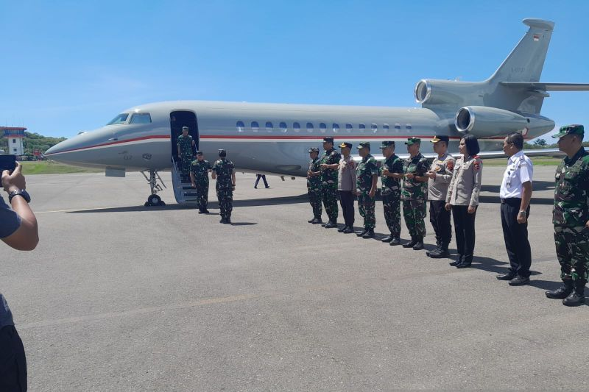

TNI Commander Admiral Yudo Margono arrives at Komodo Airport, Labuan Bajo, West Manggarai Regency, Wednesday, 19 April. ANTARA/Ho-Penrem 161/Wira Sakti

